Meet the American Woman Who Had Sex With 919 Men in a Single Day!!


American pornographic film actress Lisa Sparks has entered the Guinness book of records as she slept with the highest number of men in just a single day.
American pornographic film actress Lisa Sparks set a new world record for having sex with the most men in a single day during the annual World Gang Bang Championship in Warsaw, Poland on October 16, 2004.
Sparks competed against two other women one of which was the former world record holder who had sex with 759 men in a day.
Shockingly, Lisa is a college graduate, earning a Master of Arts degree in Multimedia with a minor in Business at the University of Kentucky
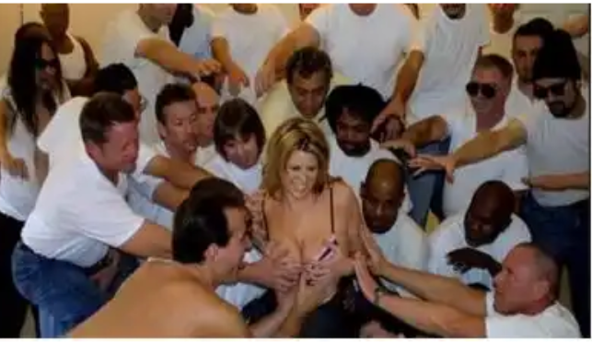

According to her: “The record is 919. It was set in ’04 in Poland. I had a blast… a little sore for a few weeks but I had fun. It was kind of like an out of body experience to be able to finish without stopping. The event was suppose to take place at an adult convention.
"However the Polish government wanted nothing to do with it. So it was a fun cat and mouse chase. I was a little nervous checking in at the airport, going through customs. I figured the Polish Government would catch up with us there. However nothing happened and I was more than happy to be on a plane for a 13 hour flight back home.”
She achieved this record by having sex with 919 men over a period of 24 hours.
CODE - Bosnia6

